**CURRICULUM VITAE**

**Personal Details**

❖ **Name:** Sadiq Jaffar Mohammed Saeed.

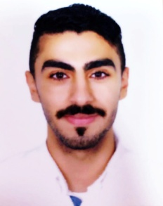❖ **CBR Number:** 000205915.

❖ **Date of Birth:** 19 /02 / 2000.

❖ **Gander:** Male.

❖ **Marital Status:** Singel.

❖ **Place of Birth:** Manama.

❖ **Nationality:** Bahrain.

❖ **Religion :** Muslim .

**Contact Details**

❖ **Address:** House NO. 1705 – Road 527 – Block 1205 –Hamad Town .

❖ **Mobile Numbers:** 37220001

**Educations**

❖ **Al Jabriya** Secondary Technical Boys School.

**Languages**

|  |  |  |  |
| --- | --- | --- | --- |
| ❖ **Arabic** | | ❖ **English** | |
| ▪ **Speaking** | Excellent | ▪ **Speaking** | Good |
| ▪ **Reading** | Excellent | ▪ **Reading** | Good |
| ▪ **Writing** | Excellent | ▪ **Writing** | Good |

**Talent & Skills:**

❖ Microsoft office power point

❖ Microsoft office Excel

❖ Microsoft office Word

**Interest**

❖ Playing Football .

❖ Watching TV .

**Others:**

❖ Have a Driving License

❖ Have a Car